Key Vocabulary
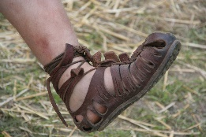  Caligae | Heavy soled military sandal-boots, worn by Roman Soldiers.
prototype | An original model that is then developed.
leather | Material made from the skin of an animal.
joining | To bring or fasten together.
reinforce | To add strength to an oject.
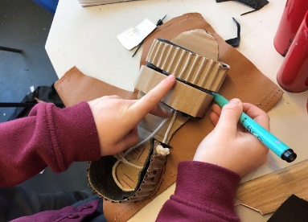
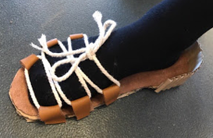
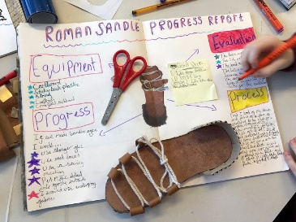
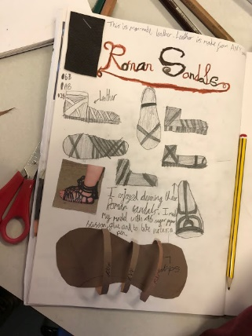
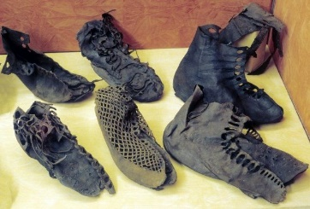
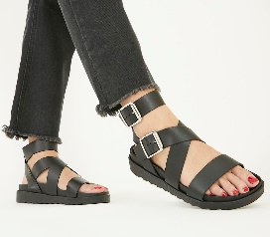
Sketch, design, make a prototype, evaluate, make the product, evaluate again.
Making and evaluating
Design Criteria
To create a sandal with a Roman style that will fit your own foot.
Can you wear it?
Is it sturdy?
How would you improve your product?

Roman Sandal: A hoard of Roman sandals were found at the fort site in Vindolanda.
Sandal: An open type of footwear, with a sole held to the wearer’s foot by straps.

Design
- To use research and develop design criteria to inform the design of innovative, functional, appealing products that are fit for purpose, aimed at particular individuals or groups.
- To generate, develop, model and communicate their ideas through discussion, annotated sketches, cross-sectional and exploded diagrams, prototypes, pattern pieces and computer-aided design.
- Make
- To select from and use a wider range of tools and equipment to perform practical tasks.
- Evaluate
- To investigate and analyse a range of existing products.
- To evaluate their ideas and products against their own design criteria and consider the views of others to improve their work.
- Technical Knowledge
- To apply their understanding of how to strengthen, stiffen and reinforce more complex structures.
Objectives
Exising Product

